TAMIL NADU GENERATION & DISTRIBUTION CORPORATION LIMITED
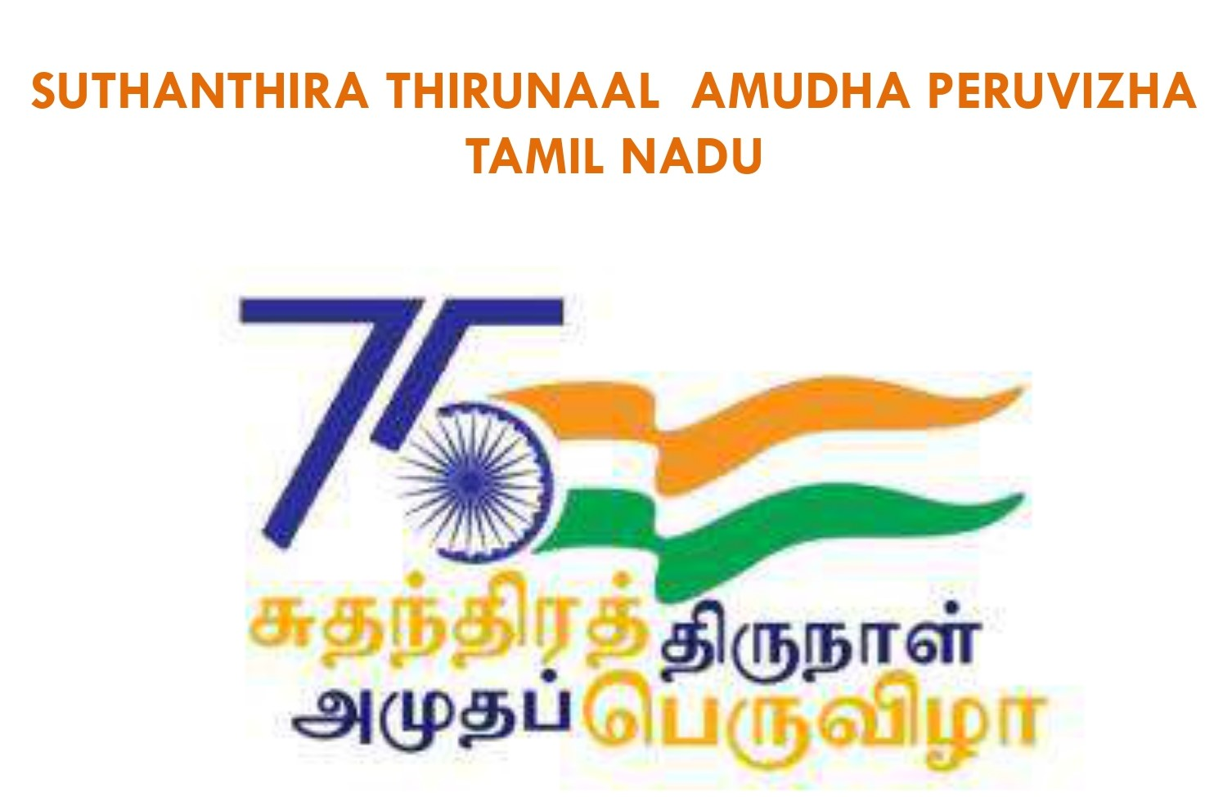
From
Er.K.Natarajan,M.Tech.,
Chief Engineer/Demand Side Management/TANGEDCO,
Chief Executive Officer/Tamil Nadu State Designated Agency,
5th Floor, Eastern Wing, 144, Anna Salai,
Chennai-600 002.
Email: cedsm@tnebnet.org
To
The Chief Education Officer,
Chennai.
Email: ceochn@nic.in
The Chief Education Officer,
Thiruvallur.
Email: ceotlr@nic.in
Lr.No:CE/DSM/SE/DVSM/EE/DSM/AEE2/F.EnergyClub/D.55 /22, dt.16.03.2022.
Sir ,
Sub: | TANGEDCO – DSM - TNSDA – Training programme to the Energy Club Co-ordinators – Schedule intimation- Reg.
Ref: | - This office letter dated 07.03.2022.  - CEO/Chennai email dt.07.03.2022.  - CEO/Thiruvallur email dt.10.03.2022

** ** **
In continuation to the references (2) & (3) cited, the training programme to the Energy Club Co-ordinators (21 Nos. Co-ordinators for Chennai and 30 Nos. Co-ordinators for Thiruvallur) has been scheduled as below:
S.No | Place | Date | Time | Venue
1 | Chennai | 22.03.22 | 10.00 a.m.to 4.00p.m. | Sree Gokulam Hotel (India) Pvt. Ltd., 67/14, 1st Avenue,  Ashoknagar, Chennai-600 083.
2 | Thiruvallur | 25.03.22 | 10.00  a.m.to 4.00p.m. | R.R.Grand Function hall,  150/3, J.N.Road, Judges Colony,  1st street, Periyakuppam, Thiruvallur- 602 001.
Hence, it is requested that the above information may please be communicated to all the participants to enable them to attend the training programme positively.
Sd***Dt 16.03.2022
Chief Engineer/DSM
Chief Executive Officer/TNSDA

Copy to the Superintending Engineer/Kanchipuram EDC
Copy to the Superintending Engineer/Chennai EDC - South 1
Copy to the Executive Engineer/General/Kanchipuram EDC
Copy to the Executive Engineer/General/Chennai - South 1EDC
Copy to the Executive Engineer/O&M/Thiruvallur/Kanchipuram EDC

Energy club Coordinators Training Programme in the Chennai District.
Date: 22.03.2022
PROGRAMME AGENDA
10.00 AM to 10.05 AM | Thamizhthai Vazhthu
10.05 AM to 10.10 AM | Welcome Address – Er.S.Krishnan, B.E.,  EE/DSM/TANGEDCO
10.10 AM to 10.15 AM | Chief Guest Address - Er.K.Natarajan, M.Tech., CEO/TNSDA, CE/DSM/TANGEDCO
10.15 AM to 10.20 AM | Spl.Guest Address Mr.S.Mars, Chief Educational Officer/Chennai
10.20 AM to 10.25 AM | Key note Address- Er.A.Anandhi, B.E.,  SE/DVSM/TANGEDCO
10.25 AM to 10.30 AM | Guest Address- Er.K.Lalitha.,B.E.,  IO/TNSDA, EE/General/Chennai EDC/South1/ TANGEDCO
10.30 AM to 10.35 AM | Memento presentation to Guests
10.35 AM to 10.45 AM | Coordinators self introduction
10.45 AM to 11.00 AM | Tea break
11.00 AM to 12.00 Noon | Lecture on Energy Club by Er.G.Ramadoss, B.E.,  AEE/DSM/TANGEDCO
12.00 Noon to 01.30 PM | Lecture on Energy Efficiency by  Er.C.Elumalai, M.E.,M.B.A.,MISTE,  AEE/O&M/Rural/Kanchi/TANGEDCO
01.30 PM to 02.00PM | LUNCH
02.00PM to 03.00PM | Lecture on Energy Conservation by Er.G.Ramadoss, B.E., AEE/DSM/TANGEDCO
03.00 PM to 03.30 PM | Feedback session / Questing and Answer
03.30 PM to 03.40 PM | Tea break
03.40 PM to 03.50 PM | Memento presentation to coordinators
03.50 PM to 03.55 PM | Vote of thanks – Er.G.Karthikeyan, D.E.E.,  AEE/DSM/TANGEDCO
03.55 PM to 04.00 PM | National Anthem

Energy club Coordinators Training Programme in the Thiruvallur District.
Date: 25.03.2022
PROGRAMME AGENDA
10.00 AM to 10.05 AM | Thamizhthai Vazhthu
10.05 AM to 10.10 AM | Welcome Address – Er.G.Karthikeyan, D.E.E.,  AEE/DSM/TANGEDCO
10.10 AM to 10.15 AM | Chief Guest Address - Er.K.Natarajan, M.Tech., CEO/TNSDA, CE/DSM/TANGEDCO
10.15 AM to 10.20 AM | Spl.Guest Address-  Mr.P.A.ARUMUGAM., M.Sc.,M.Ed.,M.Phil.,  Chief Educational Officer/Thiruvallur
10.20 AM to 10.25 AM | Key note Address - Er.A.Anandhi,B.E.,  SE/DVSM/TANGEDCO
10.25 AM to 10.30 AM | Guest Address- Er.R.Kanagarajan, B.E.,  EE/O&M/Thiruvallur/TANGEDCO
10.30 AM to 10.35 AM | Memento presentation to Guests
10.35 AM to 10.45 AM | Coordinators self introduction
10.45 AM to 11.00 AM | Tea break
11.00 AM to 12.00 Noon | Lecture on Energy Club by Er.G.Ramadoss, B.E.,  AEE/DSM/TANGEDCO
12.00 Noon to 01.30 PM | Lecture on Energy Efficiency by  Er.C.Elumalai, M.E.,M.B.A.,MISTE  AEE/O&M/Rural/Kanchi/TANGEDCO
01.30 PM to 02.00PM | LUNCH
02.00PM to 03.00PM | Lecture on Energy Conservation by Er.G.Ramadoss, B.E., AEE/DSM/TANGEDCO
03.00 PM to 03.30 PM | Feedback session / Questing and Answer
03.30 PM to 03.40 PM | Tea break
03.40 PM to 03.50 PM | Memento presentation to coordinators
03.50 PM to 03.55 PM | Vote of thanks – Er.S.Balasubramaniam, M.E.,M.B.A., AEE/DSM/TANGEDCO
03.55 PM to 04.00 PM | National Anthem

