**Examination/Most immediate e-mail/By Hand**

TAMIL NADU PUBLIC SERVICE COMMISSION

|  |  |
| --- | --- |
| From  A. John Louis, I.A.S.,  The Controller of Examinations,  Tamil Nadu Public Service Commission,  TNPSC Road,  Chennai – 600 003. | To  The Chief Educational Officer,  Presidency Higher Secondary School Campus,  Gengureddy Road,  Near F2 Police Station,  Egmore, Chennai – 600 008. |

**Letter No.1239/ID-B1/2024, dated 06.08.2024**

Sir/Madam,

|  |  |
| --- | --- |
| **Sub:** | TNPSC - Examinations - **Combined Civil Services Examination-II (Group II & II A Services -Preliminary Examination) to be held on 14.09.2024 F.N only -** Forwarding of Chief Invigilators’ Appointment orders, etc. – Regarding. |
| **Ref:** | Commission’s Letter No.1239/ID-B1/2024, dated 03.07.2024. |

*****

In continuation of the Commission’s letter cited, I am directed to say that the Examination for the posts included in **Combined Civil Services Examination-II (Group II & II A Services -Preliminary Examination) to be held on 14.09.2024 F.N only** at 38 Districts of Tamil Nadu including Chennai District.

2. Some of the school and institutes may conduct examination for the first time, therefore, it shall be ensured that the class rooms are clean and tidy with **proper furniture, adequate lighting,** fans, ventilation, adequate drinking water and sanitation facilities. Small Size benches meant for primary school children and sitting of the floor without benches shall be strictly avoided.

3. I am to say that teaching staff alone shall be appointed as Invigilators for the conduct of TNPSC Examinations and the non teaching staff like Office Assistants, Attenders, Lab Attenders and persons not related to the institutions should not be appointed as invigilators.

4. In some of the Venues there is shortage of staff which will result in non-availability of invigilators. Chief Educational Officer (CEO) / Director of Collegiate Education / Director of CBSE Schools / Director of Technical Education Chennai are instructed to provide necessary staff if need arises and this aspects may be included well ahead of the day of the examination.

5. In some Venues, mandatory condition of **“One Room Invigilator per 20 Candidates”** is being violated by C.Is when they utilise big size halls like Auditorium, Drawing Room etc., The C.Is shall be advised to follow the instruction scrupulously regarding conduct of examination and also instruction given for videographer.

6. A staff shall be arranged by the C.I to answer the Phone Calls made by the candidate to know the location of the centre.

7. Further, I am to say that upon completion of the examination on   
**14.09.2024 F.N at 12.45 P.M.** the Chief Invigilator should collect all the used OMR answer sheets pertaining to the F.N. Session and it should be tallied, properly separated as personalised portion and response portion, counted **loudly under video coverage,** packed in the self adhesive plastic covers supplied and sealed before **1.45 P.M.** Separate certificate attached to the Chief Invigilators letter has to be duly filled, signed by the concerned and sent along with Chief Invigilator’s report without fail and handed over to the Chartered Van Personnel.

8. I am also to request you to provide necessary assistance to the Hon’ble Chairman / Hon’ble Members of the Commission when they come for surprise inspection to the examination halls and to brief them about the various arrangements made for the smooth conduct of the examinations.

9. You are also requested to strictly adhere to the Guidelines / Role and responsibilities of District Authorities on various aspects of conduct of Examinations.

10. List of Examination Halls has been sent in your e-mail id.

11. I request your kind co-operation in this regard.

Sd /-Controller of Examinations

Dated 06.08.2024

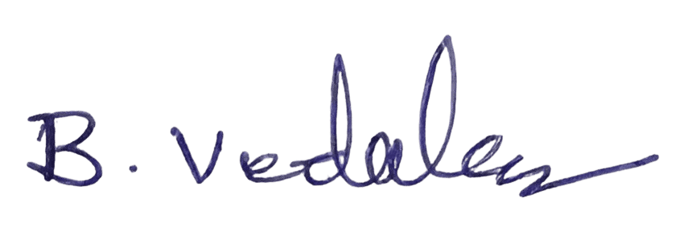

Section Officer

**CONTACT Ph: 044-25300440, 302 & 303 ;   
GPS/ Camera : 044-25300333 and 305 e-mail:** [tnpscida@gmail.com](mailto:tnpscida@gmail.com)

**Call Centre No.18004190928**